SEEDS TO SEEDLINGS
We are introducing you to the basics of growing from seeds to the seedling stage. We start with the best reasons for getting your hands dirty with gardening and what you can expect to receive from nature. Then we will be going into the technical details about what, how, where, when etc.
Growing seeds to seedlings should be a part of everyone’s life, especially for two reasons.
You will be for the most part working outdoors in the sun and in nature. This will cause you to calm down. Your parasympathetic system will increase. This means your adrenaline will lower, your blood pressure and heart rate and respiratory rate will slow. Your thinking will be clearer; you will be happier and more friendly. And even better, so will your children and the rest of your family and neighbours. You will add many healthy happy years to your life and those around you.
If you slow down enough, you will see something very tiny, hard and dry, grow, with just water, air and warmth into something thousands of times bigger. This is covered usually with soil, so in the end you just see the last bit, the stem and leaves growing skyward toward the sun. The last bit, people think they understand. Through photosynthesis, the plant converts water and minerals from the soil, using energy from the sun along with carbon dioxide, into pounds and pounds of plant. This is the start of the food chain for all life on earth.
So, these two things are part of the most important reasons why we do gardening:
- To get or keep healthy physically and mentally for ourselves and our loved ones
- To understand what is happening to our environment and how we can help Mother Nature to return health back to the environment.

For our adventure in gardening, you will decide what you want to grow. Most people will grow vegetables. Like all adventures, some will have many successes and some many failures. You will kill many plants in your lifetime, but we will guarantee, 100% that when you succeed, they will be the most beautiful, fragrant, and delicious ever. How can we guarantee this? Because as every child is loved, so, all of your plants have been cared for with utmost diligence and love and this has produced the most precious, beloved, beautiful survivors.

So let us begin to understand from Seeds to Seedlings, the TECHNICAL ASPECTS.
Seeds are bundles that have evolved over billions of years. They are tiny, containing the right amount of proteins, carbohydrates and fats, and DNA. A hundred years seems like a long time. Imagine what a thousand or a million or a billion feels like. It took several billions of years for the seeds to evolve into these semi-perfect teeny tiny compact bundles.
Here are some of the seeds we grew.
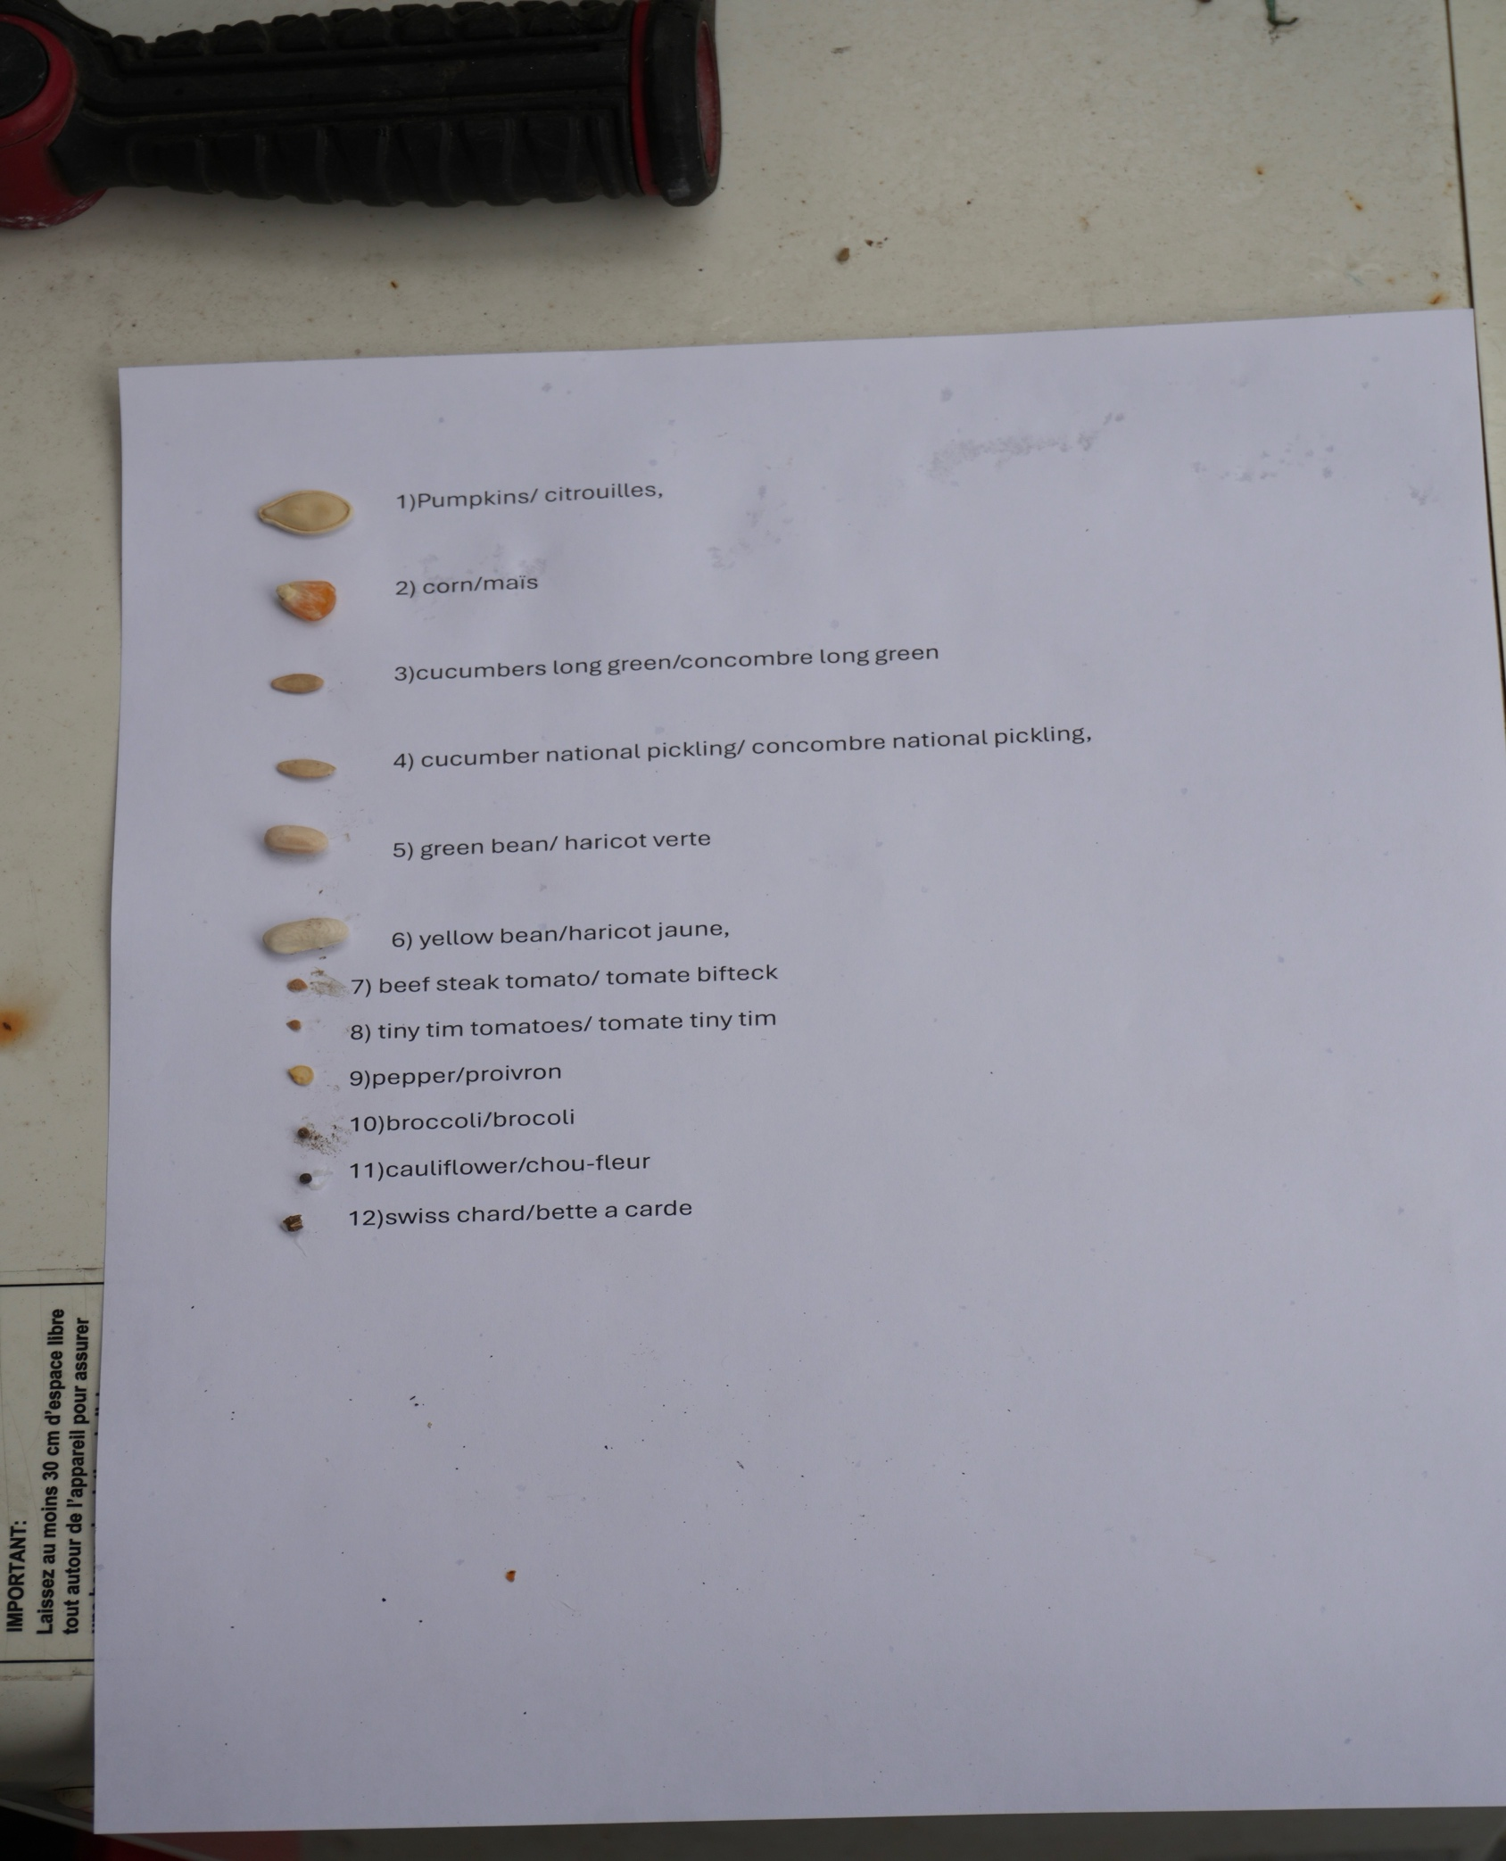
We will be talking about the seed-to-seedling stage. This is the part of the cycle that people who want to give their plants a head start find so confusing. We will try to make this as simple and as clear as possible without glibly leaving out the essential and interesting parts.
You can plant the seeds OUTDOORS or INDOORS. We will mainly discuss the indoor planting.
PART A: Let us briefly discuss outdoor planting:
1)when, the time in spring to seed outdoors
2) how deep, how wide you spread the seeds
3) where, under what shady or sunny location, soil type
4) how, much watering and fertilizer etc.

In Montreal, we are in the 6a climate zone. It describes, the average temperature, and growing season in your area. We usually have our last frost after May 21, or the end of May. If you google you will find many planting calendars for vegetable. The one we will use is by Espace pour la vie. (It is public and free). A copy is at the end of the document.
So, you know what you want to grow and if you want to just sow outdoors, just look up the planting calendar for dates to plant and look at the seed package for how deep, how much shade, ground type, watering etc.
We will return to outdoor seedling later in more detail, but the above give you an idea of what to look forward to.

PART B: Indoor planting
Mother Nature has arranged plants in basically 2 types of seeds. This is not too important, but the categories will help you identify the plants as they sprout. The seeds are:
- Dicots: these have two seedling leaves called cotyledons. These form the vast number of all plants. They can be subdivided into hypogeal where the two-seed leaves stay below ground. Examples you will see are beans, peas. Epigeal formation is where the two-seed leaves are shoved up out of the ground. The leaf veins are usually curved. These are the majority of plants you will be growing.
- Monocots: when these grow, the shoots have only one seedling leaf called a cotyledon. These plants form corn, grasses, onions, grain crops such as wheat, rye oats etc. they can be divided into hypogeal and epigeal where the single seed leaf stays below ground or is shoved above ground level. The leaves are usually parallel veined.

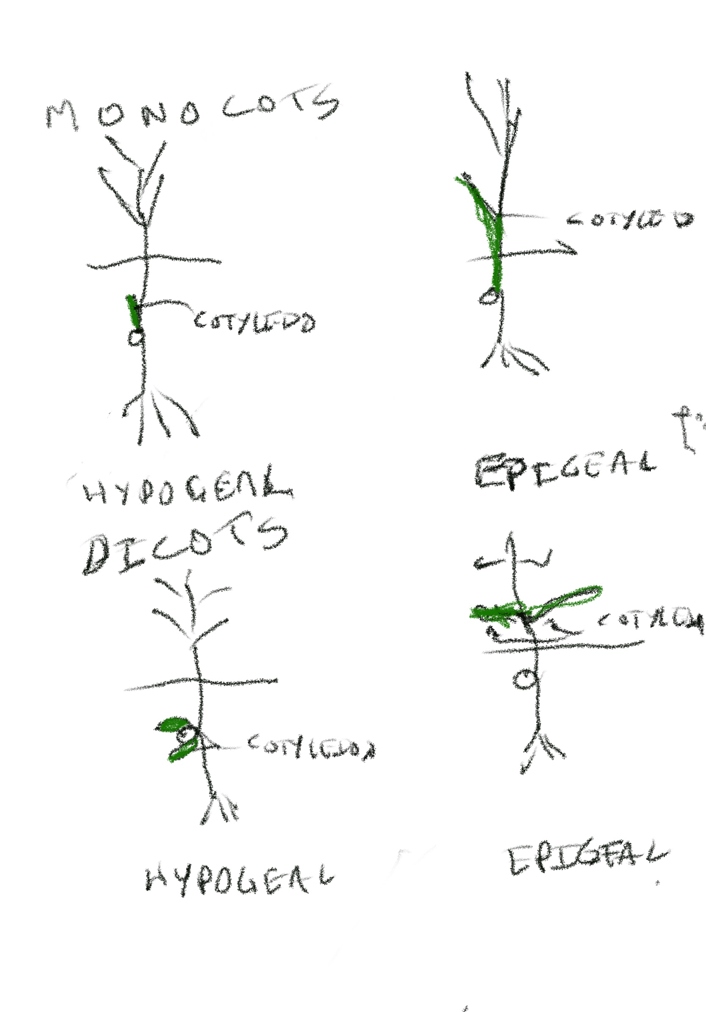

Until the shoots have many leaves the seeds only need the following. They do not need food. They can be grown in completely sterile, nutrient-free soils such as perlite. The food is contained in the seed. They do not need any fertilizer or nutrients at all yet.
- AIR
- WATER
- WARMTH
- SUPPORTIVE MEDIUM to help them grow upward
So, you can grow seeds in a variety of containers and soils. You can buy commercial growing trays for $5 each, trays from Dollarama for $1, or use old dishes, egg cartons etc.
You can buy Perlite, a white sterile medium made from volcanic glass, it costs about $10 for a small bag, Vermiculite a sterile golden material made from expanded chemicals about $18 for a small bag. Peat moss made from dried remains of moss for about $9, coconut coir made from coconut shell for about $30, seed starter mix for about $8, or weedless garden soil for about $ 2 or $3 for a 25 lb bag from IGA, Metro etc.
Many experts recommend using sterile soils to grow the seeds. All of the above are basically sterile. If you gather soil from outside, it is a living soil. A handful of living soil contains trillions of bacteria, fungi, thousands of insects and a few worms and millions of indeterminate living critters. If you do not mind having these in your kitchen or basement, you can use earth from outside, but most people do not want insects and creepy-crawlies in their house. So, it is preferable to buy potting soil from the grocery store, but remember it is sterile.
If you buy many of the above and experiment with them, you will probably find a mixture you have more success with than others. But this can get very expensive quickly, especially if you calculate the hours you spend in doing so and the clean-up in your kitchen involved.
The seed to seedling phase and potting up should be the shortest time possible. And the cheapest possible. You want to really put the crops into the ground as soon as possible without them dying from frost. The soil from the garden you will be planting them in is living. It has trillions of bacteria and fungi, worms, tiny insects, and tiny animals you need a microscope to see, medium-sized insects, algae etc. This is what your plants will be living with and cooperating with. Living soil is a living ecosystem. It breaks down the components of the soil to release more minerals and other compounds and alleviate the immediate needs for added nutrients. All of these organisms work together with your plant in a cooperative ecosystem. When seedlings have many leaves, you want to get them into real live earth as soon as possible. If you leave them too long in sterile soil, nutrient deficiencies will appear such as yellow and dying leaves. So, try to get the seed to seedling phase over as quickly and cheaply as possible.
Be realistic you will be killing a lot of seedlings, through lack of knowledge and experience and just plain bad luck. So, try to be quick and cheap and not perfect. What you mess up today, tomorrow, will give you will the experience to be more successful in the future.
What we found is the cheapest and quickest way we could get was using old containers or material from Dollarama. One of the best containers is old egg cartons which is free and you recycle waste.
Dollarama’s Garden Corner seeds from Mackenzie cost $0.33 each and had about a 100% germination rate (the exception seems to be beans). Use garden soil from a grocery store for $1 or $3. Hand loosen the soil and keep it loose, do not compact it. Keep it moist and not wet. We found it worked almost as well as all the other more expensive materials or combinations of other materials. But we are used to planting plants and judging soil dampness and compaction. These skills are best learned by doing and feeling and seeing the results. Practice makes perfect.
THIS IS HOW YOU DO IT.
So, get old egg containers or plastic or papier maché containers from Dollarama. Loosen up a bag of garden soil. Cover your worktable with newspaper or plastic or garbage bags. Fill the containers with soil, put the seeds into the soil to the depth recommended on the seed package. Place one or two seeds per container. Water the seeds and soil to dampness and put in a warm place. We do not bother to cover the soil and seeds with a cover or plastic. It is recommended that you double seed so if a seed does not germinate, you will have at least one viable seed. The problem is that if both seeds germinate, you will be forced to kill one of the seeds with a scissor. So, we would recommend only single seedlings, except for beans.
We used four types of components:
- Perlite
- Vermiculite
- Seedling mix soil
- Bagged garden soil
And we planted the same seed types in the above
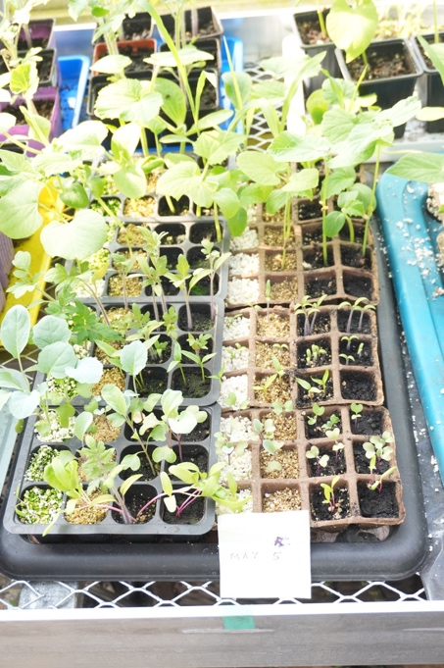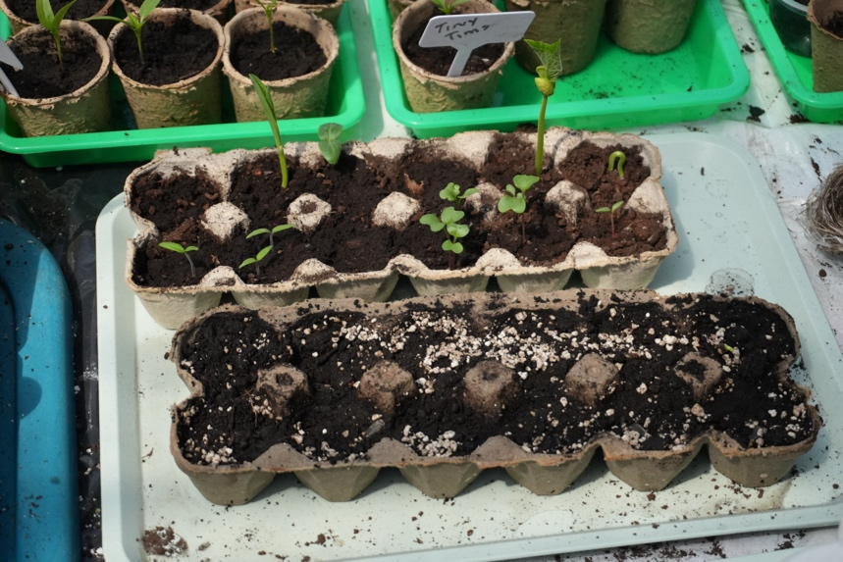
They were:
1)Pumpkins/ citrouilles, 2) corn/maïs 3)cucumbers long green/concombre long green 4) cucumber national pickling/ concombre national pickling, 5) green bean/ haricot verte 6) yellow bean/haricot jaune, 7) beefsteak tomato/ tomate bifteck 8) tiny tim tomatoes/ tomate tiny tim 9) pepper/poivron 10) broccoli/brocoli 11) cauliflower/chou-fleur 12) swiss chard/bette à carde
Keep the soil and seeds always damp, never dry or too wet. After a few days, or a week or two later, the seeds should be up and reaching for light. Put them close by a window. We mean on the windowsill as close to the light as possible. Or you can buy LED lights now very cheaply and put the bulbs a few inches away from the plants. Always keep the plants and soil damp. When the plants get too small for the container, you will need to transplant to a larger container. When you transplant, try to handle the leaves of the plant, avoid touching the stems and roots as much as possible. Once again use loosened non-compacted garden soil and transplant into damp not soaking or dry earth. Water the plant well after the transplant. Since you are using garden soil, you do not need to fertilize. There is some nitrogen and other minerals. But, if you keep them too long in the garden soil, some fertilisation will be required. There is no feedback with other living organisms to enrich the soil dead soil with new nutrients. Some of the leaves may turn yellow or die. The plants lack Nitrogen, potassium and phosphorus, that they would get from the ecosystem in a living soil. The gardens soil is not a living mixture and cannot feed the plants properly. Try to get the plants outdoors as quickly as possible. If not possible, use the cheapest form of fertilizer possible. Follow the dilution instructions and feed a dilute concentration to the plants.

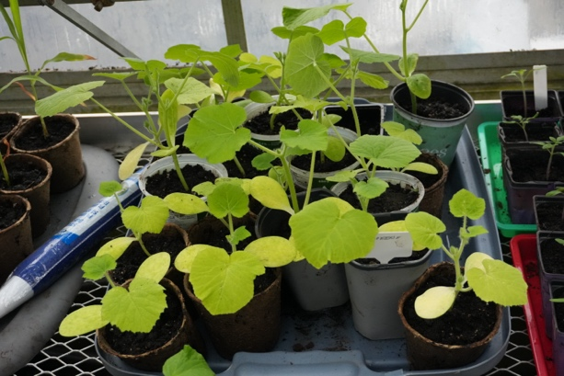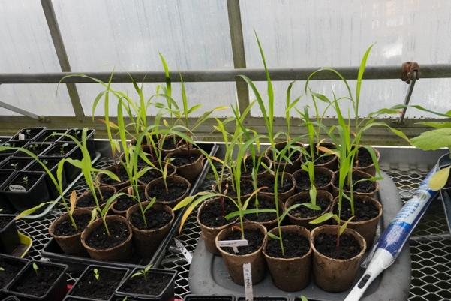
You will need to transplant as the seedlings get bigger and bigger, they need bigger pots to accommodate bigger pots
Before putting plants outside, you need to be sure they will not be killed by frost. Usually after May 21, the danger of frost has passed. You need to gradually accustom the plant to the outdoors, a few hours at a time in the morning over a few days and finally overnight if they adjust well and there is no danger of frost, then they can be planted into the ground. This time give them a good watering and say a few prayers.
AN INVITATION:
Growing is a learning-by-doing experience. You get a visceral sense by sight and touch what is too wet, what is too dry, what is too hard etc. Joan and I work usually everyday seven days a week at the back of the greenhouse at 7000 Boul Lasalle, from about 11:30 am to 3 pm. We live in NDG and have other commitments, but if you find us, we will try to accommodate you and show you some of our vegetable children. Come visit us and we will try to arrange for you to visit our indoor workshop where we have been growing our seeds. You will meet beautiful plants, although some are dying for planting outdoors, but there is still the danger of frost, and we cruelly are keeping them indoors.

SOME OBSERVATIONS ON AGRICULTURE.
- There are other reasons such as producing food to eat, to beautifying the land, to save heritage plants, to try to save money to work cooperatively with groups change society etc. But realistically, the other goals are not very achievable. For example, if you take into account the cost of your time and labour and the seeds, containers, the tools, the squirrels, birds, skunks, racoons and ground hogs and mice and voles and insects that will attack your crops, it is much cheaper to go to the grocery store to buy your food. Oz grew up on a farm in southern Ontario. The farmers work exhaustive lives of quiet desperation to make a profit, so they do not lose the land to foreclosure. You cannot and should not compete with them. Thousands of farmers are competing with thousands of other farmers for profits and survival. Oz saw as a child, the conflict between a profit and dead animals. There were thousands of dead animal corpses that tried to partake of the harvest. You do not want to do what they were unwillingly forced to do to the wildlife. Kenny Torrella of Vox, wrote May 6, 2025, that the U.S. Department of Agriculture killed 2,000,000 wild creatures last year. There are many more farmers than USDA workers. Imagine the billions of wild creatures killed by farmers last year. We grow wildflowers and have had problems with only a few squirrels eating corms and tubers. If you wish to live in harmony with wildlife, growing wildflowers might be a happy compromise.

- Industrial agriculture tries to reproduce the conditions you have created for your seedlings. They would love a completely sterile soil and then just add an adequate amount of fertilizer. The outdoors is too contaminated with living organism to just kill everything except for your crop. Industrial agriculture tries with herbicides, pesticides, fungicides etc. They try with manufactured fertilizers. The soil with very little life, compacts, the worms and insects are not long numerous, and the soil is no longer a healthy ecosystem, so agriculture uses giant harrows, inserted plastic or steel drainage pipes and extensive irrigation. We instead recommend methods such as those used by Jean-Martin Fortier and Eliot Coleman. The best stewards of the land were the indigenous peoples, and they used native crops like, the three sisters, corn, beans, and squash and blueberries, strawberries, raspberries, etc and hand tools.

- Modern society tries similar programs for urban agriculture, with artificial soils, nutrients, approved herbicides and pesticides, irrigation. The also try methods such as hydroponics, huge green houses and artificial planting containers and admixtures. We recommend avoiding all accoutrements possible and just rely on the living soil to nourish your crops. Like in the above rural agriculture, emulate the indigenous people.

- You do not have to grow vegetables. You can grow native wildflowers. They require a period of stratification. This is a period of both cold and damp. This cold damp period allows the seeds to destroy an embedded germination inhibitor. After the germination inhibitor is gone, the seed can germinate. So, in general you need to plant in the fall. There are about 50 native wildflowers that do not require stratification. Maybe next year we will put together a packet of these non-stratification seeds. But they are not as showy as many others and many are asters that will not bloom until late fall. But we will see what can be arranged.

- One of the authors we enjoy, Lyanda Lynn Haupt in her book “Rooted”, describes how as a child she confessed to her priest that she had a second church, Frog Church. She would lie on the ground with a few frogs on her belly. “We would hum and pray together, belly to belly, accompanied by birdsong and the whispers of trees overhead, and thoughts—sweet, simple, and blessedly few.” We hope everyone from time to time will experience or re-experience living in the Frog Church. We hope within five years Montreal will be the greenest city in North America. What kind of green temple, cathedral, church would this be ??? That we hope that will be decided not by the bureaucrats or the rich or powerful, but by the children, seniors and the poor.

Here is Espace Pour La Vie’s seeding and planting guide for vegetables.

The following calendar provides information on when to start seedlings in the Montréal region. These dates should be adjusted in colder areas.
Vegetables | Indoor seeding | Outdoor seeding | Successive seeding | Outdoor transplanting
Bean |  | Late May | Every 10 days until the end of June for bush beans.
Beet |  | Late April or early May | Every 2 weeks until the end of June.
Bell pepper and chili pepper | Mid-March to late March |  |  | Early June
Broccoli | Early April |  |  | Mid-May
Brussels sprout | Early April |  |  | Mid-May
Cabbage | Early April |  |  | Mid-May
Cabbage (Chinese) |  | Early August
Carrot |  | Late April or early May | Every 2 weeks until the end of July.
Cauliflower | Early April |  |  | Mid-May
Celeriac | Mid-March |  |  | Late May
Celery | Mid-March |  |  | Late May
Chard | Early April | Early May |  | Mid-May
Corn |  | Late May
Cucumber | Mid-May | Early June | Second seeding possible indoors in early July and transplanting 15 days later; replaces less vigorous plants. | Early June
Eggplant | Mid-March |  |  | Early June
Garlic |  |  |  | October
Ground cherry | Early April |  |  | Early June
Kale | Mid-March | May | Every 3 or 4 weeks to harvest young plants. | Early May
Kohlrabi | Late April | Early May | Every 2 weeks until early September. | Late May
Leek | Early March |  |  | Early May
Lettuce | Mid-April | Early May | Every 2 weeks until the end of August. | Late May
Melon | Mid-April to late April |  |  | Early June
Mesclun |  | Late April or early May | Every 2 weeks until mid-September.
Onion | Early March | Early May  (green onion) |  | Early May
Parsnip |  | Late April or early May
Peas |  | Late April or early May | Every month until early summer.  Sowing possible in early August (early cultivars).
Potato |  |  |  | Mid-May
Pumpkin  and other winter squash | Early May | Early June |  | Early June
Radish |  | Late April or early May | Every 2 weeks until mid-June.  Sowing possible in late August, early September.
Rutabaga |  | Early June
Shallot (French) |  |  |  | Early May
Spinach |  | Mid-April | Every 2-3 weeks until mid-June. Seeding possible in mid-August.
Tomatillo | Late April |  |  | Early June
Tomato | Late March to mid-April |  |  | Early June
Turnip |  | Late April or early May | Every 2-3 weeks until early June. Seeding possible from early August to late August.
Zucchini  and other summer squash | Early May | Early June |  | Outdoor transplanting

